**Program / Project Name MISYS-33/34: Currency Overlay (Hedging) Requirements**

**Program / Project No.:**

**Document Version:**

**Template Version:**

**Prepared by:**

**Group:**

**Function:**

|  |
| --- |
| RBC Investor & Treasury Services™ is a global brand name and is part of Royal Bank of Canada. RBC Investor & Treasury Services is a specialist provider of asset servicing, custody, payments and treasury services for financial and other institutional investors worldwide. RBC Investor Services™ operates through two primary operating companies, RBC Investor Services Trust and RBC Investor Services Bank S.A., and their branches and affiliates.  In the UK, RBC Investor Services Trust operates through a branch authorized by the Prudential Regulation Authority and regulated by the Financial Conduct Authority and the Prudential Regulation Authority. The Dubai Branch of RBC Investor Services Trust is regulated by the Dubai Financial Services Authority.  In Australia, RBC Investor Services Trust is authorized to carry on financial services business by the Australian Securities and Investments Commission under the AFSL (Australian Financial Services Licence) number 295018.  In Singapore, RBC Investor Services Trust Singapore Limited (RISTS) is licensed by the Monetary Authority of Singapore (MAS) as a Licensed Trust Company under the Trust Companies Act and was approved by the MAS to act as a trustee of collective investment schemes authorized under S 286 of the Securities and Futures Act (SFA). RISTS is also a Capital Markets Services Licence Holder issued by the MAS under the SFA in connection with its activities of acting as a custodian.  In Hong Kong, RBC Investor Services Bank S.A. is a restricted license bank and is authorized to carry on certain banking business in Hong Kong by the Hong Kong Monetary Authority. RBC Investor Services Trust Hong Kong Limited is regulated by the Mandatory Provident Fund Schemes Authority as an approved trustee.  ® / ™ Trademarks of Royal Bank of Canada. Used under licence. |

Revision List

|  |  |  |  |  |
| --- | --- | --- | --- | --- |
| Ver. # | Date | Author | Description | Distribution |
| 0.01 | 04/04/2016 | Clare Scully | Initial draft to kick off documentation process | Internal |
| 1.00 | 12/04/2016 | Clare Scully | Update following internal review | Internal |
| 2.00 | 24/06/2016 | Clare Scully | Updated following feedback from Mediolanum and Cronos | All stakeholders |

Table of Contents

|  |
| --- |
| The purpose of this document is to:   * Provide a vision for the expected outcome of the project. * Act as a form of agreement, outlining project particulars and deliverables. * **Note**: Requirements do not necessarily have to be collected and presented in this artefact format. If requirements software tools or alternate formats such as use cases are being used, then printed output of these formats can be substituted here. |

Revision List 2

Table of Contents 1

1. Executive Summary 2

1.1. Project Identification 2

1.2. Related Documents 2

2. Project Description 2

2.1. Purpose 2

2.2. Critical Success Factors 2

2.3. Processes Impacted 2

2.4. Business Requirements Scope 2

3. Assumptions, Dependencies & Constraints 2

3.1. Assumptions 2

3.2. Dependencies 2

3.3. Constraints 2

3.4. Process Flows 2

3.5. Requirements 2

3.5.1. Functional Requirements 2

3.5.2. Non – Functional Requirements 2

4. Sign off Block 2

Reviewers 2

5. Appendix 1 – New Fund Identifier Code 2

6. Appendix 2 – “As Is” and “To Be” Sample Files 2

1. Executive Summary
   1. Project Identification

|  |  |  |  |
| --- | --- | --- | --- |
| Project Name |  | Project No. |  |
| Program Name | As above | Program No. | As above |
| Project Start Date | 2016 | Project End Date | 2016 |
| Project Manager | N/A | Group & Function | N/A |
| Program Manager | Kate Cullen | Group & Function | Associate Director, Client Change |
| Sponsor | Renato Moreschi | Group & Function | MD, Client Operations |

* 1. Related Documents

|  |  |  |
| --- | --- | --- |
| Document Name / Description | Author | Purpose / Comments |
| New Fund Identifier Code | Clare Scully | Code that must be stored in Cos |
| “As Is” and “To Be” Sample Files | RBC | Sample files for illustrative purposes |

1. Project Description
   1. Purpose

* Mediolanum Dublin will start to use new systems late 2016 which will result in a change to the way in which they communicate with RBC.
* These systems are FusionInvest (Portfolio & Risk system) and Intellimatch (Reconciliation system).
* Mediolanum have requested various information from RBC that will feed both systems:

**Flow: RBC -> Mediolanum (High Level)**

|  |  |
| --- | --- |
| FusionInvest | Intellimatch |
| Custody & Fund Accounting trade file for Delegate Manager trades | Custody & Fund Accounting trade files for MAML trades |
| GFP confirmation of trading | Custody & Fund Accounting trade file for Delegate Manager trades |
| FX forwards initiated by RBC (e.g. COS) | Custody positions for all asset types (MAML and Delegate Managers) |
| Corporate Actions for MAML and Delegate Managers | Valuation for all security positions held on the portfolio (MAML and Delegate Managers) |
| Custody invoice file for MAML and Delegate Managers | Settled Cash and cash movement report (MAML and Delegate Managers) |
| Estimated / Confirmed Cash Flows | GFP confirmation of MAML trading |
|  | Income (dividends) for MAML funds |
|  | Corporate Actions for MAML and Delegate Managers |
|  | Custody invoice file for MAML and Delegate Managers |

* The purpose of this document is to provide the requirements for one sub-category of the category: FX forwards initiated by RBC (e.g. COS) – a hedging fx forward report.
  1. Critical Success Factors
* Successful loading of FX forwards booked as part of the hedging program to Fusion Invest
  1. Processes Impacted

|  |  |
| --- | --- |
| Process | Impact  (New/Deleted/Modified) |
| New report specific to Mediolanum | New |
| Storing of Custody Fund Identifier in the COS System | New |

* 1. Business Requirements Scope

|  |
| --- |
| Business Requirements Scope |
| Communicating FX forwards booked as part of the hedging (Currency Overlay) program to Fusion Invest, Mediolanum’s new Portfolio and Risk Management system, on a daily basis before 12am GMT T+1. |
| Scope Inclusions |
| * All Mediolanum funds that are part of the hedging program. * Storing of new identifier, a concatenation of the Multifonds Sub-fund code and the Focus/Multifonds Manager Code in the Currency Overlay system * Provision of a new report to be diffused by FTP that captures all fx forwards booked by the hedging team. The report must include the new identifier |
| Scope Exclusions |
| * Providing the report directly from the Custody system Focus, to avoid having to retain the new fund identifier in the Currency Overlay system. It is not possible to provide the report from Focus, as some of the FX rate information required by Mediolanum is not available at the Focus system level. * Any change to any report from COS not referenced in this BRD. All existing deliverables to Mediolanum by email or FTP must remain in place. They will be supplemented with this new report. |

1. Assumptions, Dependencies & Constraints
   1. Assumptions

|  |  |  |
| --- | --- | --- |
| Description of Assumption & Context | Impact if Not True | Recommended Action /  Resolution / Comments |
| Mediolanum/Cronos do not have a specific filename convention that they need RBC to confirm to use. | Requirements set out in this document may not be fully correct | Mediolanum/Cronos to formally confirm requirement  Update 12/04: Confirmed filename is required. This will be added to the requirements list. |

* 1. Dependencies

|  |  |  |
| --- | --- | --- |
| Description of Dependency | Impact if Not in Place | Recommended Actions /  Resolution / Comments |
| Resource – Mediolanum/Cronos to review docs and be available for UAT and queries | Delivery timeframe requested by Mediolanum may not be met | Schedule to be shared with all parties once available |
| Set up of functionality for RBC to push file to Mediolanum’s SFTP site, This is being progressed as a separate item with Mediolanum and is not in place at the time of writing of this document. | N/A | Details of SFTP to be shared closer to delivery date |

* 1. Constraints

|  |  |  |
| --- | --- | --- |
| Description of Constraint | Impact if Not in Place | Recommended Actions /  Resolution / Comments |
| Technical constraints may be identified as part of the IT detailed analysis | All requirements may not be able to be delivered | Results of detailed analysis to be shared with all stakeholders once available |

* 1. Process Flows

High level ‘to be’ flows are outlined below. Mediolanum system information has been included for illustrative purposes.

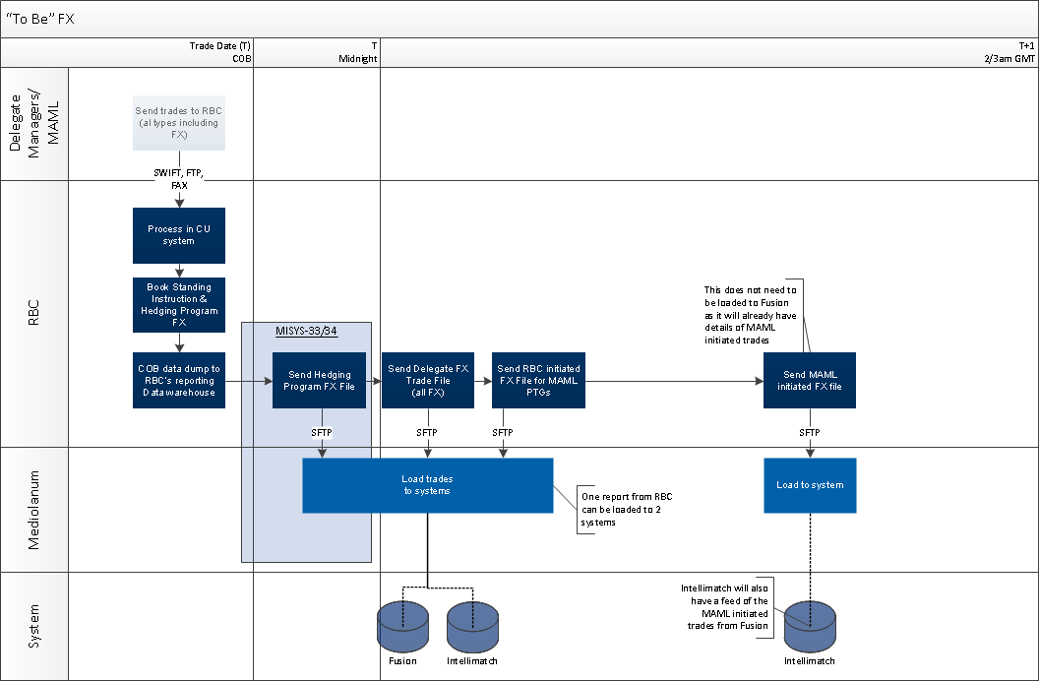

* 1. Requirements
     1. Functional Requirements

|  |
| --- |
| General Requirements |
| Client Requirements  Product, Features & Options  Marketing & Sales  Communications  Credit & Risk  Other   |  |  |  |  |  |  | | --- | --- | --- | --- | --- | --- | | ID | Requirement | Priority  1=high  5=low | Stability  High  Med  Low | Origin | Benefit | | CR1 | Report sent daily on T before 12am GMT on T+1 with details of all FXs booked on T as part of the hedging program.  The report must include the fees taken by RBC on each FX, reported as an amount and not as bps. | 1 | High | Mediolanum | To load hedging program FX information to Fusion Invest | |
| Operational Requirements |
| Operational Requirements   |  |  |  |  |  |  | | --- | --- | --- | --- | --- | --- | | ID | Requirement | Priority  1=high  5=low | Stability  High  Med  Low | Origin | Benefit | | OPR1 | Create a new Mediolanum specific report capturing the requirements set out in OPR2-OPR9.  A description of all fields in the report is provided in table 1.1. A sample ‘to be’ report is in Appendix 1. | 1 | High | Currency Overlay | To meet client requirement | | OPR2 | Report must be in CSV format.  Delimiter preference is semi-colon | 1 | High | Currency Overlay | To meet client requirement | | OPR3 | Report must be sent to Mediolanum by FTP. Details to be confirmed at a later date.  The files must be pushed directly to Mediolanum’s server.  T&O are working on these requirements separately (see Dependencies section) | 1 | High | Currency Overlay | To meet client requirement | | OPR4 | Report must be sent daily by cob – prior to midnight GMT.  The report must be scheduled. | 1 | High | Currency Overlay | To meet client requirement | | OPR5 | Report must capture all Mediolanum funds that are part of the currency hedging program | 1 | High | Currency Overlay | To meet client requirement | | OPR6 | Report must be sent even if no FX trades are executed on a given date | 1 | High | Currency Overlay | To meet client requirement | | OPR7 | Report must capture a new type of fund common identifier – a concatenation of the Multifonds sub-fund code and the Focus manager ZCode  Data for this code must be stored in COS at fund setup level in the field “Investment Manager ID”. | 1 | High | Currency Overlay | To meet client requirement | | OPR8 | A once off load of the new code referenced in OPR7 to the field “Investment Manager ID” in the Fund Setup screen on the COS application should be managed.  For more information on the field that will be used, please refer to Appendix 2.  For a list of the values to be loaded, please refer to Appendix 1. | 1 | High | Currency Overlay | To meet client requirement | | OPR9 | The report must have a specific target filename:  MAML_TRADEFILE_COS_YYYYMMDDHHMMSS | 1 | High | Currency Overlay | To meet client requirement |   Table 1.1 Field description  The below report format is modeled on an existing Currency Overlay report – TransactionsbyMaturity. Mediolanum do not currently receive this report, and the existing report parameters do not meet Mediolanum’s requirements as it’s designed to pick up trades with a particular maturity date. However the basic field contents are in line with what Mediolanum require. Fields 21, 22 and 23 are not in the TransactionsbyMaturity report and are new.   |  |  |  |  | | --- | --- | --- | --- | | ID | Field Name | Field Description | Format | | 1 | Legal Entity | Entity with whom the FX is placed – this will always be BANK” | Alpha | | 2 | COS Id | COS trade ID | Numeric (0 decimals) | | 3 | Entity Code | Multifonds Sub-Fund Identifier | Alpha Numeric | | 4 | Share Class | Share Class Type | Alpha | | 5 | Base Currency | ISO currency code of the base currency | Alpha | | 6 | Client Name | Promoter name | Alpha | | 7 | Basic Contract # / Account # | BLS account/PTG level identifier | Numeric (0 decimals) | | 8 | Fixed Currency | 1st leg ISO currency code – the amount that is to be hedged | Alpha | | 9 | Counter Currency | 2nd leg ISO currency code – base currency of the fund | Alpha | | 10 | Direction | Indicator on whether the currency in field 8 is the buy or sell currency from the fund’s perspective | Alpha | | 11 | Instrument Type | FX type  (will always be FX Fwd as the rollovers are booked 5 days in advance of maturity they are booked as forwards and not spots) | Alpha | | 12 | Trade Date | Trade date | DD/MM/YYYY | | 13 | Maturity Date | Maturity date | DD/MM/YYYY | | 14 | Fixed Amount | Amount for the leg referenced in field 8  Figures must be in absolute value | Numeric (2 decimal places) | | 15 | Client Spot Rate | Spot rate | Numeric (4 decimal places) | | 16 | Client All-In Points | Margin taken by RBC  Note: RBC only take a margin on the hedging roll over trades, so on most dates the value in this field will be 0 | Numeric (4 decimal places) | | 17 | Client All-In Rate | Final rate applied to the trade | Numeric (4 decimal places) | | 18 | Contra Amount | Amount for the leg referenced in field 9  Figures must be in absolute value | Numeric (2 decimal places) | | 19 | Status | Status of the FX | Alpha | | 20 | Mandated Execution Time | Indicates the time at which the FX is placed.  Based on the current setup the 4pm GMT rate is used – as a result the field records a time of 5pm CET | HH:SS | | 21 | External Fund Identifier | New common fund accounting and custody identifier required by Mediolanum. This is the new id referenced in OPR7 and OPR8 above.  This value will be stored in the Investment Manager ID field on the Fund Setup screen.  Please refer to Appendix 2 for a screenshot and Appendix 1 for a full list of the codes to be stored in this field. | Alpha Numeric | | 22 | Fees Currency | ISO currency code of the fees quoted in field 23. This will be expressed in EUR, which in Mediolanum’s case will always be the contra currency / base currency of the fund.  Currency must always be quoted even if the figure is 0. | Numeric (2 decimal places) | | 22 | Fees in Amount | In field 16 the margin taken by RBC is quoted in bps. Mediolanum also require this figure quoted as an amount.  If there is no fee 0 must be reported | Numeric (2 decimal places) | |
| Third Party Requirements |
| Third Party Requirements |
| Measurement Requirements |
| Measurement Requirements |

* + 1. Non – Functional Requirements

|  |  |
| --- | --- |
| Non- Functional Requirements | |
| Audit  Business Continuity  Data Retention  Documentation / Training  Fraud  Privacy  Volume Impact  Security  Availability  Hardware  Software  Reliability  Scalability  Performance  Interface  Infrastructure |

1. Sign off Block

|  |  |  |  |  |
| --- | --- | --- | --- | --- |
| Role | Name | Group & Function | Signature | Date |
| Project Manager | Noel Nolan | Mediolanum |  |  |
| Program Manager | Kate Cullen | RBC |  |  |

## Reviewers

Reviewers are acknowledging that they have reviewed the Business Requirements and are in agreement with the content.

|  |  |  |  |  |
| --- | --- | --- | --- | --- |
| Role | Name | Group & Function | Signature | Date |
| Mediolanum | Lizy di Vetta | Mediolanum |  |  |
| Mediolanum | John Burrows | Mediolanum |  |  |
| Cronos | Steve Lazouras | Cronos |  |  |
| Cronos | James Shillingford | Cronos |  |  |
| SME | Kerrin Pick | COS |  |  |
| SME | Eric Cockenpot | COS |  |  |
| BSA | Karim Mouhoud | IT |  |  |
| BSA | Delphine Tempesta | IT |  |  |
| IT PM | Sebastien Paulissen | IT |  |  |

1. Appendix 1 – New Fund Identifier Code



1. Appendix 2 – Screenshot: Investment Manager ID

New fund identifier will be stored in the below field on the COS – Fund Setup screen:

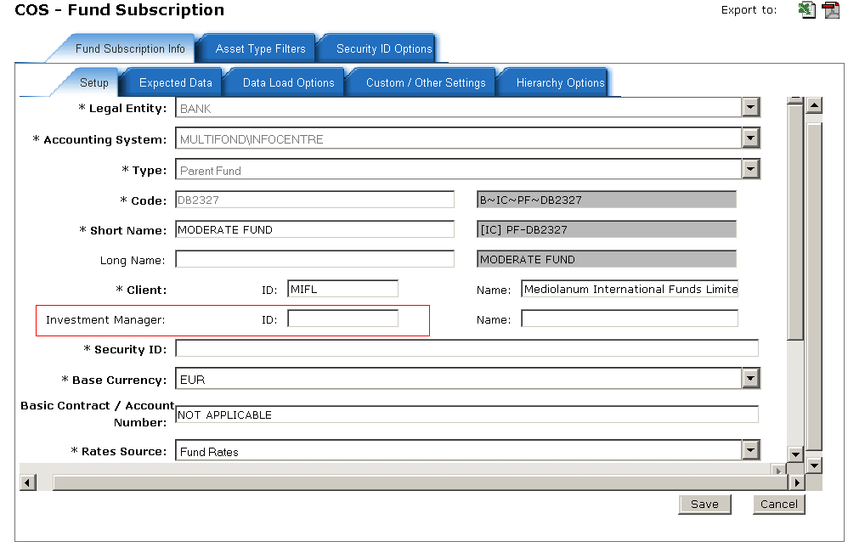

1. Appendix 3 – Sample “as is” and “to be” files

“As Is”



“To Be”

The sample is in XLS for illustrative purposes but must be a CSV delimited file.

